APPENDIX 1

**PILLS BOOTH**

**A PROJECT REPORT**

**Submitted by**

**DHARUN KRITHIK K**

(411720104013)

**GOPINATH V**

(411720104018)

**in partial fulfilment for the award of the degree**

of

**BACHELOR OF ENGINEERING**

in

**COMPUTER SCIENCE**

**PRINCE SHRI VENKATESHWARA PADMAVATHY ENGINEERING COLLEGE, KANCHEEPURAM**

**ANNA UNIVERSITY: CHENNAI 600025**

APRIL 2023

**APPENDIX 2**

**ANNA UNIVERSITY: CHENNAI 600 025**

**BONAFIDE CERTIFICATE**

Certified that this project report “**PILLS BOOTH”** is the bonafide work of “**DHARUN KRITHIK K** and **GOPINATH V**” who carried out the project work under my supervision.

**SIGNATURE SIGNATURE**

**HEAD OF THE DEPARTMENT SUPERVISOR**

**ACKNOWLEDGEMENT**

First and foremost, we wish to express our sincere thanks to our FOUNDER AND CHAIRMAN **Dr. K. VASUDEVAN,M.A.,B.ED.,PH.D.,** and VICE CHAIRMAN **Dr. V. VISHNU KARTHIK., MBBS., M.D.,** For his endeavour in educating us in this premier institution.

We wish to express our appreciation and gracefulness to ur DEAN,**Dr.V. MAHALAKSHMI, M.E., Ph.D.,** for her encouragement and sincere guidance.

We are highly indebted to our PRINCIPAL., **Dr. G. INDIRA, M.E.,**

**Ph.D.,** for her valuable guidance which has promoted our efforts.

We also wish to convey our thanks and regards to our HEAD OF THE DEPARTMENT, **Dr.M.PREETHA., M.TECH, Ph.D.,** for her support and for providing us ample time to complete our project.

We would like to express our sincere gratitude to our PROJECT COORDINATER, **Mrs. REENA M.E., (Ph.D.),** Department of Computer Science and Engineering,for her guidance and support throughout our project.

We want to sincerely thak ou PROJECT SUPERVISOR, **Mr. M.DIVYA BHARATHI, M.E.,** Department of Computer Science and Engineering,for her leadership and assistance during our project.

We wish to convey our sincere thanks to all teaching and non-teaching staff of the Department of Computer Science and Engineering,without whose coordination this venture would not have been a success.

**ABSTRACT**

In India there are still some rural areas, where there are no hospitals or medical facilities available. As we cannot put them behind in our advancing world, using today’s technology we can help them to take care of themselves for small diseases without doctor’s presence. Also when one journeys from long routes trains and highways and if suddenly his health condition becomes worse and there will be no hospitals or medical facilities available at such places. There are many medicines available in a market which can help in such situation but due to non-available to one at time of need, may cause a loss of life. Our system covers the development of a medicine vending machine intended for use in remote areas which provides basic medicine on the basis of symptoms. However there are so many challenges under this approach.one major concern is correct medicines according to the ages and expiry date checking problem.The software will be programmed such as when the patient select’s a particular option the person will be provided with that required option.

|  |  |  |
| --- | --- | --- |
| **CHAPTER NO** | **TITLE** | **PG NO** |
| **1** | **INTRODUCTION** |  |
|  | 1.1 SMALL INTRODUCTION |  |
|  | 1.2 PROBLEM DEFINITION |  |
|  | 1.3 OBJECTIVE OF THE PROJECT |  |
|  | 1.4 MOTIVATION |  |
| **2** | **LITERATURE SURVEY** |  |
| **3** | **ANALYSIS** |  |
|  | 3.1 EXISTING SYSTEM |  |
|  | 3.2 PROPOSED SYSTEM |  |
|  | 3.3 REQUIREMENT SPECIFICATION |  |
|  | 3.3.1 SOFTWARE |  |
|  | 3.3.2 HARDWARE |  |
| **4** | **SYSTEM ARCHITECTURE** |  |
| **5** | **DESIGN** |  |
| **6** | **CONCLUSION** |  |

**CHAPTER 1**

**INTRODUCTION**

* 1. **SMALL INTRODUCTION:**

The growing modern age has also brought with it the dawn of the age of numerous types of diseases.The use of medicine to maintain and regain physical and mental health.The doctors prescribe different type of medicine for one particular type of illness.

1234567890‘’“”

2nd International conference on Advances in Mechanical Engineering (ICAME 2018) IOP Publishing

IOP Conf. Series: Materials Science and Engineering 402 (2018) 012044 doi:10.1088/1757-899X/402/1/012044

Today it has become common for a person to take at least one type of pill at regular interval each day .

But in case of the elderly people the scenario is awful. They take numerous number of pills at one particular time of the day to maintain their health.

It is not possible for them to carry a medicine dispenser with them.

Even if they carry all the medicine strips with them, there is good chance that they might forget which pill to take.

* 1. **PROBLEM DEFINITION:**

The problem to be addressed is the need for a medicinal system or a device which can be used to take medicine in any particular time necessary generally in remote areas they lack hospital facility or medical shop or medical centre even shops in some place.This leads to severe health issues and may be prompt to diseases .

Especially during covid times people goes to medical shop for medicine So even that may lead to the spread of disease .

To overcome this issue we have brought this pills booth which is a little compact machine which can be placed anywhere around the globe.

This machine works similarly to coffee vending machine where the user enter their need and coffee is given accordingly so this machine works in the sameway.

The challenge is that it should identify the particular age group and proper prescriptions should be given accordingly,it must also check for the expiry date of the particular pills which we are putted in the machine.

* 1. **OBJECTIVE:**

The medicine availability also has a major impact excluding the factor about complete cure. The aim of this Device is that temporary relief is to be given out that can give people a better chance for Keeping the health in a good state before they are able to reach doctor. Major advantage is that people would be able to access the medicines in malls, bus, railway stations, on highways, areas where medical stores are limited. Those with poor health tend to fall into poverty and the poor tend to have poor health. Our project although may not be an out of the box idea in its entirety, it still could prove useful. Especially in developing countries like India where there are innumerable numbers of people who are unable to avail medicines.In this project the system will contain three medicines like medicines for fever, cold, headache.

* 1. MOTIVATION:
* Around 65% of indian population lacks regular access to medicine.
* Today the total value of the health sector is more than $34 billion.
* Availability of medicine in public sector in all states is 0-30%.
* The private sector accounts for more than 80% of total healthcare spending in India.
* In india 10 person/min get injured in road accident
* According to the report by the Registrar General of India, the leading causes of death are senility (23.5%), circulatory diseases (10.8%), causes peculiar to infancy (9.6%), and fevers (7.7%). In terms of morbidity, it is estimated that about 2-3% of the population suffers from some kind of illness everyday.

**CHAPTER 2**

**LITERATURE SURVEY:**

In “ZhardEM Medicine Vending Machine”, The aim of the project was to implement a business idea that would provide a solution to a particular problem with use of microcontrollers, in particular Arduino or Raspberry Pi. One of the constantly overlooked problems in the Nazarbayev University is the absence of twenty-four-hours medicine provider. There is a medical center, but it does not work at night, and the only pharmacy is located not in the main dormitory. Thus,the medicine vending machine is designed to fill this gap.The types of medicine that are to be offered do not require a prescription, therefore there is no need for a medical specialist and special permissions. Also, the number of products offered will be small and consist only of the most frequently used medicament types that can be usually found in a first-aid kit. In “All Time Medicine and Health Device”, a prototype of the All Time Medicine and Health device was developed for people in need of medicines and health-care. It constists of a vending machine to provide drugs prescribed by a doctor for anyone who requests it. Raspberry-pi, a single board computer is used for the operation of the vending machine. The are two parts of this system a physical vending machine, and a online interface for doctors to provide prescriptions electronically and a database to store patient information and prescriptions. To get the medicines one must authenticate himself by providing his user credentials. There are two interfaces for the portal, an android application and a website, users can access either and check all their details after yielding their user credentials. In “Any time medical assistance and medicine vending machine using machine learning”, the main aim was to make a device that can be installed in public places and could be accessed by anyone at anytime of the day. The naïve bayes algorithm was used to classify the data. And basic health measurement equipment were to be placed in the machine, like a simple blood pressure, blood sugar and temperature measurement devices. This system is to be linked to a vending machine to dispense respective medicines. It’s basic aim is to treat small medical ailments and and to give first aid. In “Automatic Medicine Vending Machine”, the basic aim is to dispense medicine based on the user’s requirements. The is a smart card system for authentication, the information from the user’s smart card and his/her keyboard input is sent to the microcontroller for processing. Then with the help of the motor drivers present on the machine.

Medicines are placed in separate compartments, and when needed the motors from the respective compartments which the user’s requested medicines are present and those medicines are wielded to the user.

|  |  |  |  |  |
| --- | --- | --- | --- | --- |
| S.NO | AUTHORS | PAPER TITLE | DESCRIPTION | PUBLICATION |
| 1. | Sarika Oundhakar | Automatic Medicine Vending Machine | It is used as a medicine vending machine | IJETSR Volume 4 |
| 2. | prudhvinandan | Medco app box | The data is collected from the medical box and display in the app,its stored in cloud | Paper 2017  IEEE |
| 3. | ”Abhishek Singh | Touch Screen Based Automated Medical Vending Machine | Based on the user input medicine will be given | IJIRST Volume 1 |
| 4. | A.J.jara,M.A.Zamora-Izquierdo,A.F.Skarmeta | Interconnection framework for health and remote monitoring based on IOT | Monitoring the health condition using IOT | IEEE journal on selected areas and communication  Vol.31 |

**CHAPTER 3**

**ANALYSIS**

**3.1 EXISTING SYSTEM**

The problem arises when the need for some medicine is urgent and drug stores aren’t open or pill isn’t available ,especially during really dark .in remote areas,rural areas,and places where public turnover is a smaller amount the supply Of medicine within the patient reach may be a critical issue.These are some of the main problems that are being faced by the society in present scenario.Degrees of social status are closely linked to health in equalities.those with poor health tend to fall under the poverty and there fore the poor tend to possess poor health.According to the planet Health Organization,within countries ,those of lower ecomic have the worst health outcomes.

The poor within most countries are trapped in a cycle of poverty.our project may be a out of box idea it could sustain as a useful one.Especially in developing countries like india where people cant afford medicine,they are band aids for minor cut ,paracetamol for reducing fever,ORS packets for dehydration and other problems in body.

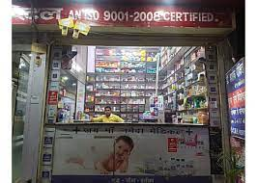

**3.2 PROPOSED SYSTEM:**

The micro controller is programmed to group all the pills in timely basis i.e. all the pills that are to be taken in the morning is grouped. Then the specific pill is picked by the carousal as per the request. The pills fall on the feed chute and then to the conveyor ,a slot provided in the storage rack. The guide placed in the conveyor guides the pills to fall into the funnel that puts the pills inside the aluminum foil bag. Then these pills are packed in an individual aluminum foil bag. This type of packing aids in neglecting confusion to the user. Also a brief description of the medication in the bag is printed by the non-contact inkjet printer. We have also added scanner to pay money accordingly as the in future money will be in a digital format.we are making this device smaller compared to others as it can be portable and can be mainly fitted in trains which lack medical facility in india.we are also adding body temperature measuring sensor so that it can give prescription accordingly.

**3.3 REQUIREMENT SPECIFICATION**

**3.3.1 SOFTWARE REQUIREMENT:**

1.Products

•Ability to change price and name of product

•Ability to add and remove stock

2.Payment

•Refunding of money should be dynamic.

•Inform user that he is unable to buy a certain product if there is no change available.

•Payment by card would result in the appropriate amount being deducted from it.

•User has the option to insert both cash and card.

3.Display

•User will only be to select up to the maximum number of stocks left.

Constraints

1.Payment

•Although user can insert both cash and card, he is allowed to pay using only one of

them.

2.Shelf/Products

•Each machine, once created, will have a fixed number of shelves and products

per shelf. It is not possible to add one more shelf, or remove a shelf from it. This is to simulate a real vending machine, whereby you can have an empty shelf, but you cannot

remove the shelf itself from it.

The benefits :

1."Convenience", speed

2.24h/7 availability

3. "Versatility": machines can sell almost any product

4.A wide range of payment options

5.Clean, hygienic, safe, always at the right temperature

6.Machine branding adaptable to the clients requirements (schools, banks etc)

7.Flexible placing options (sell, lease or rent)

Operators:

The machines are managed by (the so

-called) operators. They run the machines as their core business. They conclude commercial agreements with

companies or public institutions for the

placing of the machines, invest funds into the

hardware, and are responsible for cleaning and filling the

machines

**3.3.2 HARDWARE REQUIREMENT:**

1.Microcontroller:

It is a compressed micro computer manufactured to control the function of embedded system.The MSP430 family of microcontroller from T1 are considered as some of the modern microcontroller

2.Passive infrared sensor:

It is used to detect body heat by looking for changes in temperature.it is mostly used in home security system

3.exhaust fan:

To remove stale,muggy or removing dirty air.

4.barcode Scanner:

It is inbuilt to read the prescription to the user.

5.Servo motor:

It is used to control the speed for giving out the medicine

6. A non-contact laser inkjet printer:

It prints all the necessary descriptions like the expiry date of each pill in the bag and the time at which the medication is to be taken by the user.

**CHAPTER 4**

**SYSTEM ARCHITECTURE**

Design of the machine:

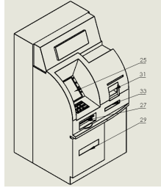 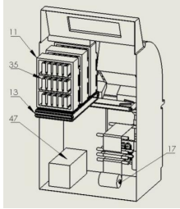

Fig 1. User side Figure Fig 2. Inside the machine

The design is based on simplicity and the utilizations of low cost materials and components that can

be easily available . Figure 1 and 2 shows the major components of the preferred embodiment which

includes a major housing that hold within it the central micro controller, a scanner that takes the input

from the user; storage space that houses small containers where all the different type of drugs are

stored; a conveyor series that takes the pill form storage to packing region; a small size industrial

standard vertical foam fill packing machine; a dispatch area for the user to receive the packed medicine.

1234567890‘’“”

2nd International conference on Advances in Mechanical Engineering (ICAME 2018) IOP Publishing

IOP Conf. Series: Materials Science and Engineering 402 (2018) 012044 doi:10.1088/1757-899X/402/1/012044

Design of the user interface:

Referring now to figure 1, the user interface is ergonomically designed so that even the least of the

untaught people will be able to easily access the facility on their own. The user has to put the printed

prescription in the small slot like space provided. The slot contains an inbuilt barcode scanner that can

read the prescription. The prescription mentioned here is different from the customary practice of

written prescription. The prescription is in printed format containing the relevant barcodes of the

medicine and the dosage being recommended. The prescription is prepared using a special computer

application that is specifically designed to get the name of the medicine from the physician and then

the barcode is automatically put in the respective space in the prescription with the help of an offline

database that contains all the barcodes of the medicines available in the market.

The user need to manually input the time of the day in which the medicine is being prescribed. For

example, a particular pill may be prescribed to be taken in the morning and afternoon and another may

be prescribed to be taken only at night. After these information are given, the user can view the total

amount of the medication for a single day. Then the user is prompted to enter the number of days he

desires to buy the medication. At last the grand total for the entire medication is displayed.

A money transfer system is provided to receive money from the user for the medicine via a debit or

a credit card. The user is prompted to enter in the details and accepts the terms of the payment to be

made. Once the payment process is complete, the user receives a printed description of the detail of the

money transfer made. Then the controller signals the packing mechanism to start the packing of the required pill(s).

Design of storage space:

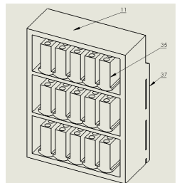 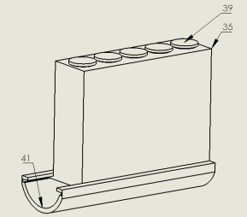

Fig 3. Isometric view Fig 4. Design of receptacle

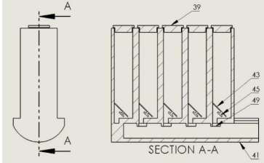

Figure 5. Cross sectional view of the receptacle

Referring now to figure 3 and 4, the storage space contains a number of receptacles. Each

receptacle is divided into ten individual compartments to contain different type of pills. The divisions

are cylindrical with an oblique bottom. All these container are made air tight to avoid the reaction of

pills with the moist air or being contaminated by dust. Figure 5 shows that each division is provide

with a unique servo attached to a carousel at the bottom. An infrared slot sensor is placed beside the

servo to detect dispensing of pill. The carousel is used to pick an individual pill to be packed with other pill that is to be taken at the particular time as per the prescription.

When the receptacles are loaded with new batch of pills, the inventory is updated manually by the

person who is refilling. Also the expiry date of the particular batch is updated. The main controller

keeps track of the inventory with the help of signals from the infrared slot sensor.

Medicines that are more frequently used by people are stored in more than one division to ensure

that the pill doesn’t run out of inventory very soon. The feed chute that take the pills from receptacle to

the packing section are sealed tightly to avoid being contaminated by the atmosphere and to maintain the purity of pills while moving out of the storage.

Design of pill singulation system:

The pills are put into the receptacle as a whole bunch. So there is need to isolate one pill from the plurality of pills in the container. The servo motor placed at the bottom of each division of receptacle does the work.

Each division of the receptacle is angled upward from the upper mouth, so that the pill dispensing

end is positioned above the input end. In this fashion, the pills that are fed through the chute move

upward against gravity. This oblique bottom wall helps to centralize the pill. The pill dispensing

mechanism is rotationally controlled using the servo motor by the main controller.

The carousal at the bottom has two small slots that are 180° apart at the periphery of the circular

disc that is attached to the servo motor. This slot in the disc helps in singulation of the pill. When the

servo motor is signaled to rotate, the slot picks up only one pill and rotates along with the carousal. A

small hole is placed at the bottom of the division just a little below the carousal. When the slot and the

hole match, the pill is dropped to the feed chute which eventually leads to the packing section. The

number of slot can be increased to reduce the operating time and increase efficiency.

The infrared slot sensor placed adjacent to the servo motor makes sure that one pill is dropped per

half rotation of the carousal disc. The signal from the sensor is used to activate the packing

mechanism, track the flow of pill and is also used to maintain inventory of medicines.

Dust builds up in the sensor over a long working period. Thus maintenance and cleaning of the

storage is necessary to assure accurate pill count and equipment life is an economically important

consideration

Description of packing system:

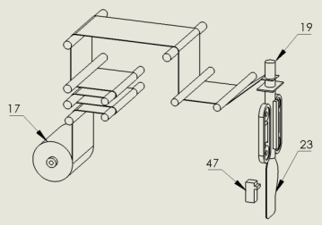

Figure 6. Vertical foam fill machine with non Contact

Referring now to figure 5 and 6, the pill is taken from the receptacle to the packing area through the

feed chute. The medication is packed in an aluminum foil bag using an inbuilt smaller version of an

industrial standard vertical foam fill machine. The machine is loaded with aluminum foil roll which is

used for blister packing in pharmaceutical industry. Aluminum foil's keep out moisture,

microorganisms, light, oxygen and other gases. Thus making it a primary material in the protective

packaging of pharmaceuticals. The pills are made to fall through the opening into the bag for packing.

The foil is fed into the packing machine and the pills are packed one batch at a time. Batch, here

refers to the set of tablets that are to be taken at a particular time of the day. As the packing process

continues, a non-contact laser inkjet printer prints all the necessary descriptions like the expiry date of

each pill in the bag and the time at which the medication is to be taken by the user.

Brief of the entire operation of the machine:

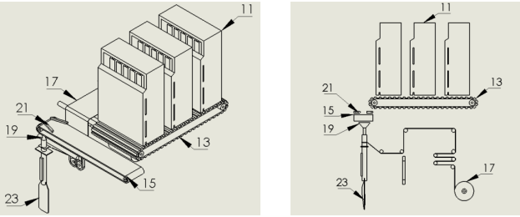

Fig 7. Total assembly Fig 8. Side view of assembly

1234567890‘’“”

2nd International conference on Advances in Mechanical Engineering (ICAME 2018) IOP Publishing

IOP Conf. Series: Materials Science and Engineering 402 (2018) 012044 doi:10.1088/1757-899X/402/1/012044

Referring now to figure 7 and 8, the user is requested to insert the printed prescription provided by

the physician into the slot provided. Some of the sensitive medicines are not to be legally provided to

the user without a doctor’s prescription. Another option can be included in the user interface to allow

for the user to take some of the commonly and ‘not very sensitive’ medicines from the vending

machine without a doctor’s prescription in emergency cases. The scanner which is inbuilt in the slot

scans the printed prescription for the barcode corresponding to the medicines. The medicine details are

then displayed on the screen.

The user need to manually input the time of the day in which the medicine is being prescribed.

After these information are given, the user can view the total amount of the medication for a single

day. Then the user is prompted to enter the number of days he desires to buy the medication. At last the grand total for the entire medication is displayed. After this the user is requested to pay the money

for the medication. Only then the dispensing function will begin.

The micro controller is programmed to group all the pills in timely basis i.e. all the pills that are to

be taken in the morning is grouped. Then the specific pill is picked by the carousal as per the request.

The pills fall on the feed chute and then to the conveyor via a slot provided in the storage rack. The

guide placed in the conveyor guides the pills to fall into the funnel that puts the pills inside the

aluminum foil bag. Then these pills are packed in an individual aluminum foil bag. This type of

packing aids in neglecting confusion to the user. Also a brief description of the medication in the bag

is printed by the non-contact inkjet printer. This process is carried out till all the necessary pills have

be packed.

Once the process is over, the dispatching door is signaled by the micro controller to open through

which the user can take the medicine that is packed as per the request.

**CHAPTER 5**

**DESIGN:**

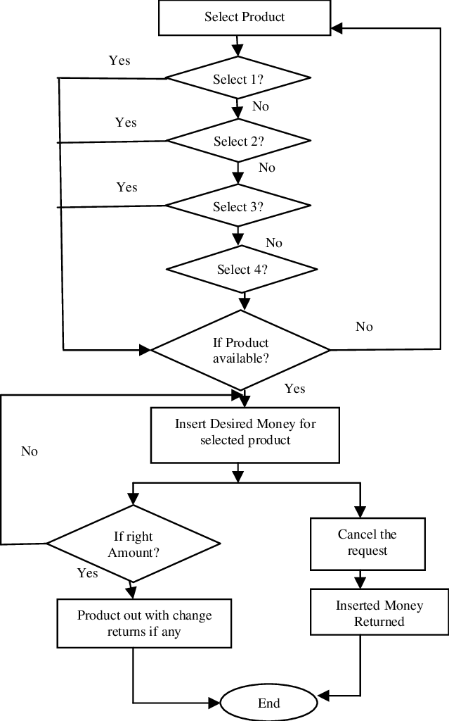

**CHAPTER 6**

**CONCLUSION:**

The 24/7 pills booth offers a flexible and simple solution for extending basic healthcare to all places, at a very moderate cost. The machine will dispense prescribed medicine. The machine adds an intelligent medicine unit, which sends a refill notification message to the nearest pharmacy when the number of medicine strips decrease below a certain level. The intelligent pillbox is technically feasible to all the peoples. It will be very helpful and it gives ease of access. It is sales person-less service which will be based on camera. It is important to consider how the technology may affect quality of medication delivery and use.

The pills booth provides medicine for general symptoms like fever, cold, headache. This machine can be installed at bus stations, railway stations and streets of the city.

**REFERENCE**

1.Bhagya Shree S R, Chandra Shekar P, ‘Automated Medication Dispensing System’, 2015 IEEE. 2.KahtanAziz , ‘Real-Time Healthcare Monitoring and Tracking System using GSM/GPS Technologies’, August 2016 IEEE.

3. Mahaveer Penna, ’Design and Implementation of Automatic Medicine Dispensing machine’, May 2017 IEEE.

4. Vishal Tank, Sushmita Warrier, ‘Medicine Dispensing Machine Using Raspberry Pi and Raspberry pi Cont

5. “Automatic Medicine Vending Machine” Sarika Oundhakar IJETSR Volume 4, Issue 12 December 2017

6. “Automated Medicine Dispensing Machine” Shraddha Kadam, Aishwarya Kale, Punam Nimase, Sheela Padwal, Shobhit Khandare IJETSR Volume 4, Issue 3 (May-June, 2016)

7. “Automatic Medicine Vending Machine” Shrikant Bhange, Kaveri Niphade, Tejshri Pachorkar, Akshay pansare IJARECE) Volume 4, Issue 3, March 2015

8. “Touch Screen Based Automated Medical Vending Machine” Abhishek Singh IJIRST Volume 1 Issue 11 April 2015